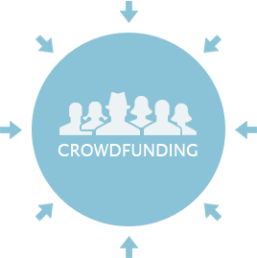

Crowdfunding platforms like Kickstarter and Indiegogo have been growing in success and popularity since they began in the late aughts. Everyone from indie creators to famous celebrities have utilized crowdfunding to launch new products and generate buzz, but not every project has found success.

**Campaigns Analysis by Category:**

Journalism, technology and photography had the highest success rate out of all campaigns. Great Britain was the top country when we are comparing the success rate among geos.



**Campaigns Analysis by Sub-category:**

When we are looking by sub-category plays have the most numbers of pledged:

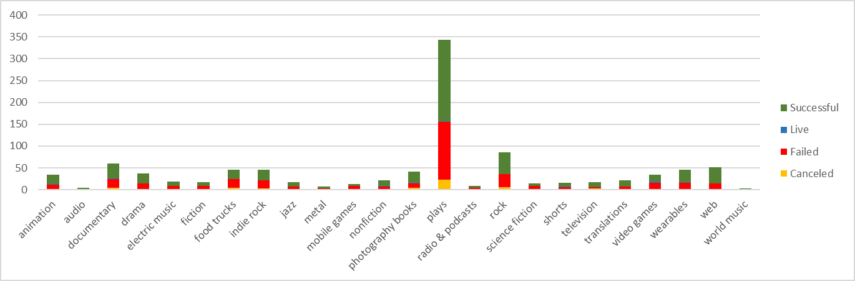

and as we can see below US is the country that people are more engaged with it.



**Campaigns Analysis by Year & Month:**

June and July have the highest success rate and the overall result of the campaigns was successful:

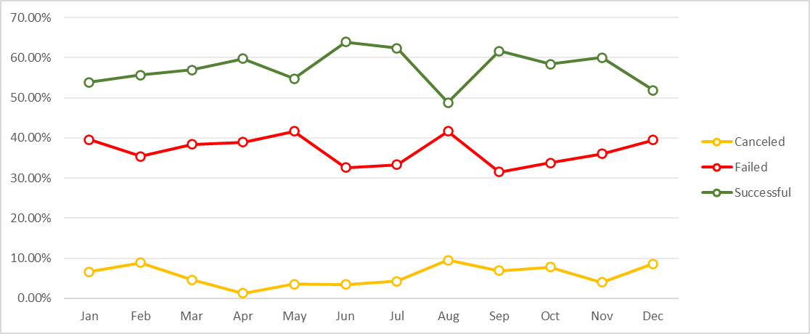

**Crowfunding Goal Analysis:**



After analysis, we can determine that the current dataset has a limitation on the genders, ages of the backers and other population information that can help in some optimizations. Another point that would be helpful is financial information about the backers.

Other possible tables and graphs:

* + Pledged by country.
  + Pledged by category.
  + Pledged by sub-category.
  + Goal by country.
  + Goal by category.
  + Goal by sub-category.

This information could give us a better understanding of the project’s finances and help to plan the following campaigns by category, sub-category and country.